**Table of contents**

Chapter 1 Introduction

1.1 Background and Motivation

Chapter 2 Radar Systems and Data

2.1 MCoRDS

2.2 ATM

2.3 Ku Band Altimeter

Chapter 3 Study Area

3.1 Petermann Glacier

3.2 Jakobshavn Glacier

Chapter 4 Theory and Methodology

4.1 Ground Penetrating Radar

4.2 Methodology

4.2.1 Geometric Spreading loss

4.2.2 Englacial Attenuation

4.2.3 Abruptive Index

4.2.4 Coherence Index

4.2.5 Specularity

Chapter 5 Roughness Estimation

5.1 Theory

5.2 Data and Methods

5.3 Roughness Measurements from ATM

5.4 Roughness Measurements from Ku Band Altimeter

5.5 Application

Chapter 6 Englacial Attenuation

4.1 Previous methods

4.2 Modified Englacial Attenuation

4.3 Layer Method

Chapter 7 Results and Discussion

7.1 Roughness

7.2 Englacial Attenuation

7.3 Reflectivity

7.4 Validation

Chapter 8 Conclusions

References

**Chapter1**

**Introduction**

* 1. **Background and Motivation**

With the global climate change and temperature rise there’s constant effect on the polar ice sheet thus making significant change in the rise of sea level.

Greenland ice sheet mass loss has doubled in last two decades (Shephard 2012) as a result of increased ice discharge into oceans and increased melting of ice sheets. This phenomenon contributes about 0.6mm per year global sea level rise (Furst 2015).Monitoring sea level change is important for different aspects as it threatens lives in coastal areas and islands.

Huge efforts have been made to study the ice sheet conditions especially the Antarctic and Greenland ice sheet which can bring about a significant change in the sea level rise. ICESat part of NASA's Earth Observing System, is a planned satellite mission for measuring ice sheet elevation and sea ice freeboard, as well as land topography and vegetation characteristics [wiki]. Similarly Operation IceBridge uses RADARs, LIDARS and other sensors to measure ice sheet conditions. The large ice sheets of Greenland and Antarctica contains enough ice to contribute to a sea level rise of roughly 70 meters if all ice were to melt completely (Shepard & Wingham, 2007).

Several models have been proposed to explain the ice sheet conditions and are constantly being used to explain the ice conditions. Ice sheet dynamics play important role in explaining the glaciers and melting. Ice motion is affected by two main factors i.e. temperature and the strength of the bases. A lot of ice breaks due to the melting of ice sheets both superficially as well as the basal melting. The ice slides due to basal melt which is caused by high pressure from thick ice sheet. The melting point of water decreases with the increase in pressure thus thicker glacier are likely to cause basal melt as well as they also provide thermal insulation meaning higher temperature favorable for melting. Ice sheet loss is then caused due to sliding of ice sheets into the oceans.

Ice core drilling and seismic analysis have been used to understand the ice sheet conditions however it is not feasible to cover whole of the ice sheet and tend to require more time and effort so airborne ice-sounding radar is a powerful technique for understanding ice sheets and glaciers and their contiguous underlying environments with less efforts.

Ice penetrating radars have been used to locate ice surface, ice beds, detect internal layers and ultimately the thickness of ice sheet. Further studies have focused on interpreting echoes to characterize the subglacial environments of ice sheets. Specifically, echo amplitude analyses have provided images of the subglacial interface [Neal, 1979; Bentley et al., 1998] and supported the discovery of subglacial lakes [e.g., Oswald and Robin, 1973; Robin et al., 1977] as well as determined the location of ice sheet grounding lines [Uratsuka et al., 1996]. Studies using echo fading and amplitude statistics have provided estimates of small-scale roughness or the localized slope distributions of reflecting facets [Oswald, 1975; Neal, 1982].

A coherent radar system detects both the amplitude and phase of the radar signals and has a number of advantages over incoherent radar systems. For example, coherent signal integration from a moving airborne platform forms a synthetic aperture radar (SAR) that improves along-track resolution. With SAR, echoes can be resolved from the subglacial interface that otherwise are obscured by crevasse scattering (Figure 1). Furthermore, analysis of coherent radar echoes can better quantify reflection and scattering from an interface than incoherent radar analysis.

Basal melting is one of the necessary condition for basal sliding and ice surface velocity so understanding basal conditions locations is crucial for modeling ice dynamics. Bed echo reflectivity has been used to infer the basal conditions (Peter 2005, Oswald 2008) given that wet beds have higher reflectivity than frozen beds. But due to variable spatial attenuation sometimes dry beds are interpreted as wet beds. High Specularity, smooth bed and high waveform abruptness have also been used along with bed reflectivity to constrain the locations of wet beds.

This thesis studies the basal conditions of two important outlet glaciers of Greenland i.e. Jakobshavn and Petermann glacier using different attenuation models. The radar data collected by Center for Remote Sensing of Ice sheets under Operation Ice Bridge has been used to derive the basal conditions of these two glaciers.

**Chapter 2**

**Radar Systems and Data**

**2.1 MCoRDS**

The Center for Remote Sensing of Ice Sheets (CReSIS) deployed airborne Multi Channel Coherent Radar Depth Sounder (MCoRDS), a nadir looking radar mounted on an aircraft flying usually at the height of 500 meters from the ice surface to map the thickness of Greenland and Antarctica ice sheets in NASA’s Operation Ice Bridge (OIB) missions [13,19]. This analysis uses the data at Petermann glacier and Jacobshavn glacier from 2008 to 2014 seasons [14]

MCORDS system has evolved over the years and the specifications for each season can be obtained from CReSIS (cresis.ku.edu). MCoRDS operates with linear chirp waveform within the frequency band from 180 MHz to 210 MHz (2012 season). It usually has six transmit channels and receivers to allow beamforming during data processing. An Arbitrary waveform generator (AWG) is used to generate the waveforms which is pre-stored in digital form and converted to analog form using a D/A converter [6]. Three different pulses are used. The short pulses of 1 μs and 3 μs are used to detect the surface and shallow ice layers and doesn’t have high penetration power whereas 10-μs pulse is better in detecting the ice bed as it has higher penetration power. The short and long pulses are alternatively sent with time division multiplexing at pulse repetition frequency of 12 KHz. The received signals are digitized using A/D converters at sampling rate of 111MHz or 150 MHz with 14 ADC bits. Table I. describes some basic radar system parameters.

###### TABLE I. MCoRDS SYSTEM PARAMETERS

|  |  |
| --- | --- |
| **Parameter Description** | **Value** |
| Center Frequency | 195 MHz |
| Bandwidth | 180-210 MHz |
| Transmit Signal Type | Linear Up Chirp |
| Transmit Power | 1050 W |
| Pulse Repetition Frequency | 12 KHz |
| Signal Duration | 1 μs, 3 μs and 10 μs (Low Altitude) 30 μs (High Altitude |
| Transmit Channels | 7 |
| Receive Channels | 15 |
| Noise Figure | 2 |
| Sampling Rate | 111/150 MHz |
| ADC Bits | 14 |
| Data Rate | 32 MB/sec per channel |

The complex data received after processing from this radar without coherent integrations has along track resolution of about 0.5 m and 25m when SAR processed. The resolution in ice is about 4.3 [Gogineni ]. The surface illuminated by the radar or its footprint is important is deriving the surface roughness. For any radar, the footprint bounded by compressed pulse length is given by [11]:

$${\text{D}}_{\text{PL}}\text{=2}\sqrt{\frac{\text{hc}}{\text{∆f}}}$$

where ‘h’ is the height of the aircraft from the surface, Δ𝑓 is the bandwidth of the radar signal. For MCoRDS, the flying height is typically 500 meters and the bandwidth being 30 MHz the radar footprint thus averages around 141 meters for ice surface and for average ice depth of 2000 meters, the footprint is around 316 meters.

## 2.2 Airborne Topographic Mapper (ATM)

Surface roughness calculations are also made from the Airborne Topographic Mapper (ATM), a conical scanning airborne laser developed at NASA Wallops Flight Facility to monitor the earth’s topography. ATM measures the surface frequency of 5 kHz and a scan rate of 20 Hz [18]. The along-track resolution is 3-4 m with laser footprint of ~1m. The primary data product L1B of ATM is QFIT, which is dense surface elevation measurements. It is condensed into ICESSN which fits a plane to the block of points selected at regular intervals (0.5 sec) along track with overlapping of 50% between successive blocks [17]. It also measures the South-North and West-East slope for the plane and RMS fit of the ATM data to the plane. The radar lines of MCoRDS coincide with the track 0 of ICESSN data. ICESSN data has along-track resolution of 80 meters and hence the RMS height from this laser system is calculated by the interpolation for the corresponding radar locations.

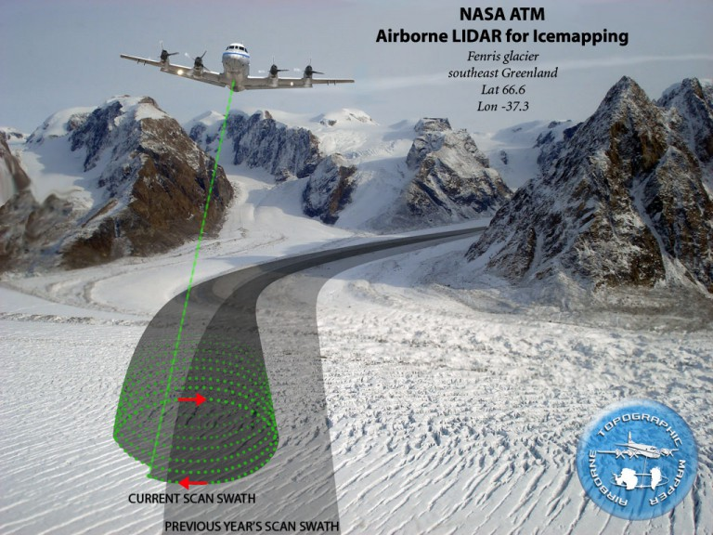

Fig. Airborne Topographic LIDAR (ATM)

## 2.3 Ku Band Altimeter

Operation IceBridge missions also employ the Ku-band Altimeter developed by CReSIS which is an Ultra Wideband Frequency (UWB) Modulated Continuous wave (FMCW) radar operating usually from 12-18 GHz [19]. It provides high precision surface elevation measurements over polar ice sheets. The along-track resolution of the data from Ku- band is 0.2 meters after hardware presums.

# Chapter 3

# Study Site and Data

## 3.1 Petermann glacier

Peterman glacier is one of the rapidly changing outlet glaciers in Northern Greenland that drains more than 4% of the total ice sheet. The glacier is situated around 81°N and 61°W and flows from south-east to north-west. The 90 km long fjord has deepest bed upto 1100m below the sea level. The ice tongue thins from nearly 600m thickness at the fjord front to around 100m at glacier front [Munchow] with ice thinning caused due to melting of underside ice by warm ocean water.[Rignot ,Steffen].

Petermann glacier has the second-longest floating ice shelf in Greenland with a permanent floating ice tongue [24,25], and flows with an average velocity of just over 1 km per annum [22].

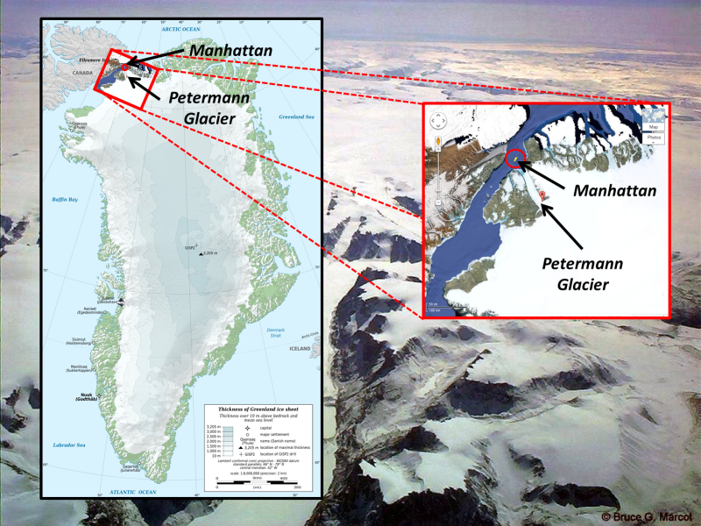

Fig. Petermann glacier

Two huge glacier calving events have occurred at Petermann Glacier over the past 5 years, one in 2010 (270 km2) and another in 2012 (130 km2) [22, 23]. The findings of Nick et al. (2012) and Grant 2013, show that the subglacial melting plays a critical role in the dynamics of Petermann Glacier, and understanding it can help predict future calving events.

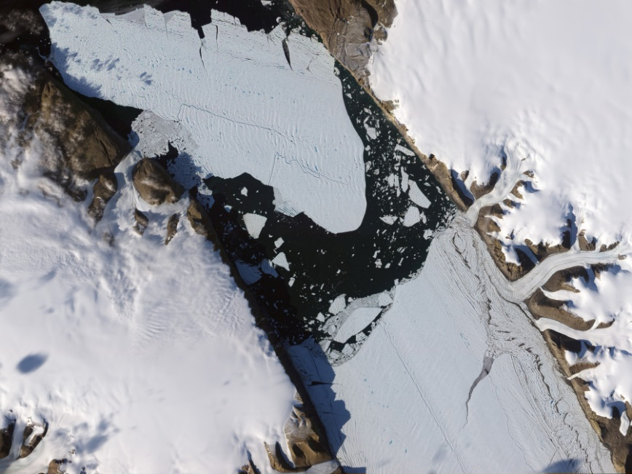

Fig. 1 Petermann glacier ice tongue

## 3.2 Jacobshavn glacier

Jacobshavn glacier is in South West Greenland, the fastest moving glacier on earth which has very high ice calving rate. It now flows approximately at 1250myr-1 and drains nearly 7% of the total ice sheet [Bindschadler,1984] through 50 km long fjord to a bay. It forms at the confluence of two ice streams, a short slow one from the north and a long fast one from the east [Fastook]. Much of the floating tongue of jacobshavn isbrae has collapsed resulting into the accelerating of the glacier. This may be due to warming of the ocean water causing sub ice shelf melting or the subglacial drainage system in the catchment area.

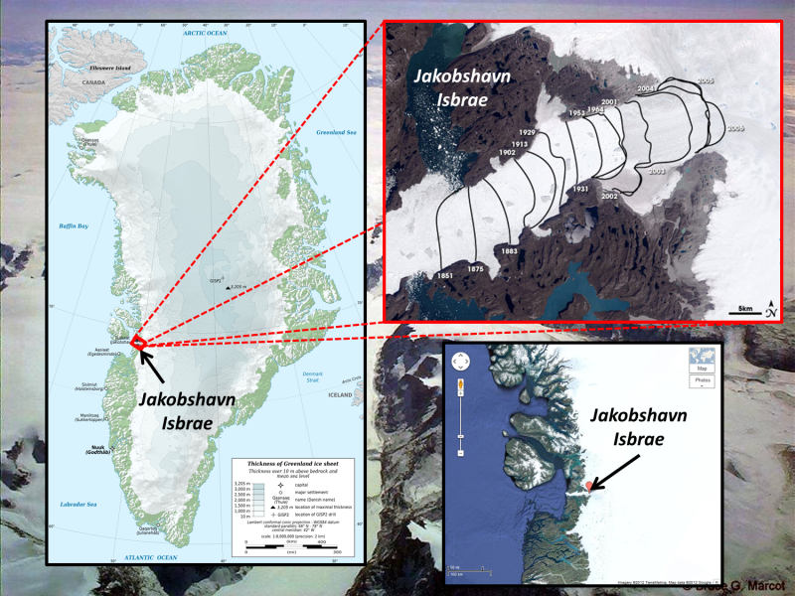

Fig. 2 Jacobshavn glacier

The glacier’s high flow acceleration and mass loss in addition to calving fromt retreat shown in figure 3 has become major concerns for the stability of the glacier. A recent large calving of approximately 7 km² took place on February 15, 2015. Understanding the ice dynamics of this glacier is thus very important.

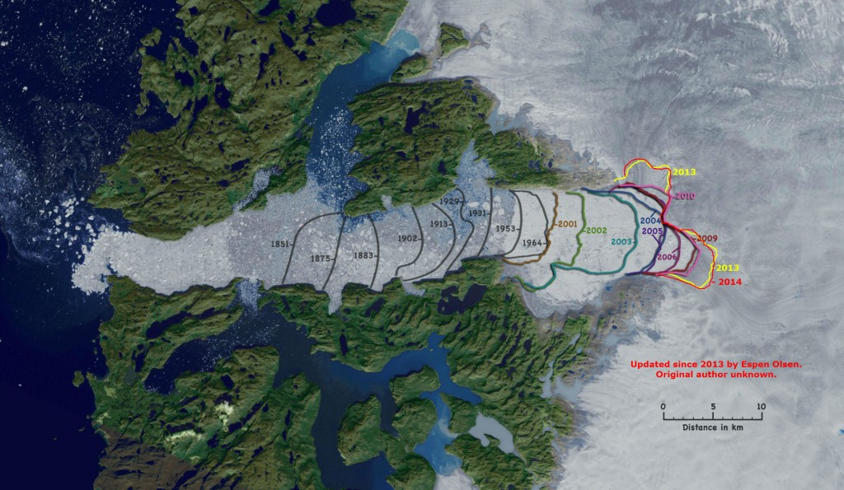

Fig. Jacobshavn glacier grounding zone in various years retreating inland at very high rate

**Chapter 4**

**Theory and Methodology**

**4.1 Ground Penetrating Radar**

Ground penetrating radars have been used to map subglacial and englacial interfaces of the ice sheet for a long time. The basic principle of an ice penetrating radar is that electromagnetic waves are sent from the transmitter through array of transmit antennas into the ice sheets where it’s backscattered whenever there is discontinuity of dielectric constant thus giving sharp backscattered echoes from the surface, internal layers and the bottom as there is transition from air to ice and ice to rock/water. The dielectric of water is 80, rock is 4-12 and 3.2 for the ice, which is why there are two sharp peaks in the received echoes. The receive antenna different from transmit antenna or the same antenna is used to capture the backscattered echoes. The data used in this study is collected by a multichannel coherent radar depth sounder (MCoRDS) which uses array of antennas for better SNR of the received echo. It uses along track focusing by SAR processing and pulse compression in fast time to generate echograms usually for every 50 km. The two way travel time for the surface and bed are then used to determine the depth of the ice sheets. Ice Surface and bottom are tracked using automatic tracker developed at CReSIS with some manual corrections.

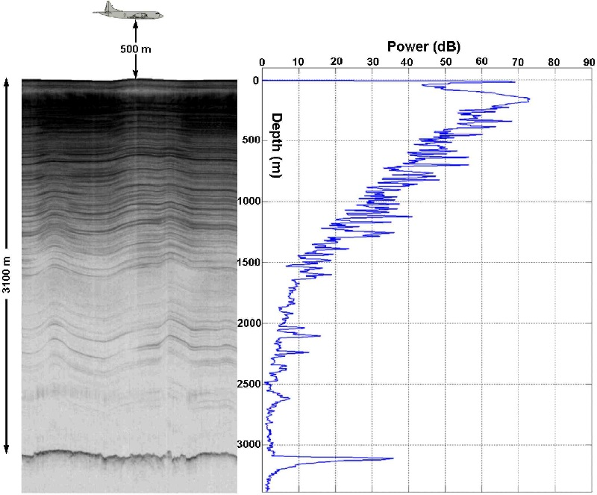

Fig. Echogram with ice layers (left) A-scope (right)

Figure shows an echogram (left) that shows ice surface, internal layers and the ice bed (at 3100m) clearly. The A-scope shows two distinct peak powers at ice surface and the ice bed.

This bed can be rock of different dielectric constants 4-12 or could be water of dielectric constant 80. The backscattered echo strength depends on the dielectric constant hence may indicate water (wet bed) for higher reflectivity and rock for lower reflectivity (frozen bed).

**4.2 Methodology**

When signal propagates through the ice, the bed echo strength is given by the equation

[𝑃]𝑑𝐵 = [𝑆]𝑑𝐵 −[𝐺]𝑑𝐵 + [𝑅]𝑑𝐵 − [𝐿]𝑑𝐵

where bed echo strength (P) is function of radar system parameters (S), geometric spreading loss(G), bed reflectivity(R) and englacial attenuation (L). So to calculate the reflectivity ‘R’ of the bed we need tp compensate all the other parameters from the bed echo strength ‘P’. This bed reflectivity can be used to analyze whether the bed is frozen or thawed [Evans 2004, Oswald 2008].

***4.2.1 Geometrical Spreading Loss***

When the signal is radiated from the antenna then the power of the signal is continuously reduced when it travels away from the antenna. The geometric loss at ice depth $‘d’$ when radiated from an antenna with gain $‘g’$ radiating signal of wavelength ‘ $λ'$ at the height of $‘h’$ is given by

$$G=2×{[2\left(h+\frac{d}{\sqrt{ε}}\right)]}_{dB}$$

Using the two-way propagation time for ice surface and ice bed, the depth of ice sheet is calculated from which the corresponding geometrical spreading loss is derived.

Geometrically corrected bed-echo power 𝑃𝑐 is then given by

[𝑃]𝑑𝐵 + [𝐺]𝐵 =[𝑃𝑐]𝑑𝐵= [𝑆]𝑑𝐵+[𝑅]𝑑𝐵−[𝐿]𝑑𝐵

Rearranging the above equation gives

[𝑅]𝑑𝐵= [𝑃𝑐]𝑑𝐵+ [𝐿]𝑑𝐵−[𝑆]𝑑𝐵

Assuming the system is stable for a season and the losses due to birefringence negligible (<2 dB) (Fujita 2006) then correcting the ice bed power for these losses will give us ice bed reflectivity which can be analyzed to infer ice bed condition.

***4.2.2 Englacial Attenuation***

One of the ambiguities introduced in the ice sheet modeling with radar data is due to the variable ice attenuation rates. The englacial attenuation rate varies due to scattering, variable dielectric constant of snow/ice, ice impurities, and complicated internal structures within the ice sheet hence it is spatially variable. The englacial attenuation rate [L] is related to depth as:

$L=2N_{a}h$

Where $N_{a}$ is englacial attenuation rate ($dB/km$) and $h$ is the depth of ice sheet. $N_{a}$ usually ranges from 3 to 30 dB for grounded ice (Matsuoka 2012). If we assume a constant ice attenuation rate then it produces a widely spread ice bed reflectivity which can’t explain the transition between frozen and wet bed. A transition from frozen to wet bed would correspond to an increase in about 10dB (Macgregor, 2013).

The reflectivity due to dielectric constant difference can be shown as:









Here we can see that the reflectivity would be higher for ice water interface compared to ice rock interface due to difference in dielectric constant.

Hence if englacial attenuation isn’t properly compensated then a realistic bed reflectivity can’t be obtained so it’s imperative that the englacial attenuation is properly compensated. Several methods have been used to estimate the englacial attenuation and calculate the ice bed reflectivity which is discussed in Chapter 6.

Apart from these losses roughness is also another way the power loss occurs hence compensating for surface and bed roughness can yield a better bound in calculated ice bed reflectivity. Chapter 5 discusses the estimation of roughness and its compensation.

***4.2.3 Abruptive Index***

Oswald and Gogineni, 2008 have used high abruptness as another indicator of basal melt since the transition from ice to flat lying water bed gives a specular echo. Abruptive index is defined as $$I_{abr}=\frac{P_{peak}}{P_{ag}(x)}=\frac{{({\left\{P\right\}}_{X})}_{peak}}{{\{\sum{D_{int}P\}}}_{X}}$$

Where $P_{peak}$ is the bed power and $P_{ag}\left(x\right)$ is the aggregate power over the echo envelope ‘ $D_{int}'$ which is the depth bins and is given a threshold of 5% of the peak power. It’s value lies usually between 0.05 and 0.5. A threshold value of abruptive index is put upon the interface that is flat at the scale of ice depth to indicate possible basal melt.

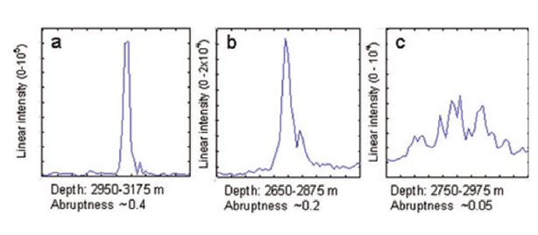

Figure 3. High Abrupt , Abrupt and less abrupt signals from flat and rough surfaces [1]

***4.2.4 Coherence Index***

To measure the interface smoothness, the coherence index of the bed needs to be calculated which is given by equation

$$I_{CO}=\frac{\int_{D_{int}}{<|\int_{X_{int}}{|{ψ\left(D,x\right)dx|}^{2}>dD}}}{\int_{D_{int}}{\int_{X_{int}}{{|ψ(D,x|}^{2}}}dxdD}$$

where D is the ice depth, x is the along track distance interval for integration, and $X_{int}$ is the along track interval for both coherent and incoherent integrations, the length of the radar footprint at ice bed, usually 200 meters, and $D_{int}$ is the aggregation interval of the basal echo envelope.

If there is water at the bed then due to pressure gradient it forms a flat surface hence the areas with flatter surfaces and high reflectivity are representative of basal melt (Oswald, 2003).

Chapter 5

Roughness Estimation

Radar has been extensively used to understand the surface properties from determining elevation changes (Helm, 2014), surface roughness (Neal, 1982; Grima, 2014), moisture content (Bryant 2007; Zribi, 2002), dielectric constant (Grima, 2012) and so on. Studies using echo fading and amplitude statistics have provided estimates of small-scale roughness or the localized slope distributions of reflecting facets (Oswald, 1975; Neal, 1982). The changes of the ice sheet conditions are being monitored by flying missions over the same place in certain time period. One of the changes that can be identified is the change in the surface roughness that can show the changing nature of ice dynamics at that place.

Roughness can be estimated from RES data using different methods like Fast Fourier transforms [9], Integral Equation Model [10] and statistical method [11]. The MCoRDS radar used by the Center for Remote Sensing of Ice sheets (CReSIS) for polar surveys can penetrate deep into ice sheets to reveal ice bottoms and the backscattered signal from the bed [13,14]. These bed echoes are analyzed to understand the basal conditions [1,15]. We apply Grima’s approach to derive roughness of the ice bed and ice surface from MCoRDS data, which can be used to model ice bed reflectivity and understand basal conditions.

Roughness is a function of the radar system parameters as it varies with the wavelength of the radar signal. Roughnesses calculated by the MCoRDS [13] are compared with that of laser altimeter by ATM group [17] and Ku Band altimeter [19]. However, RMS height is an inherent property of the system parameters [20] hence these systems are expected to have quantitatively different results but qualitatively similar results, which gives us confidence towards the calculation of ice bed reflectivity. Laser altimeter and Ku-band maps only the ice surface hence here we compare the surface RMS heights calculated from these three systems.

## 5.1 Theory

Natural surfaces can reflect the EM waves according to the nature of the surface. From specular surfaces the received field is coherent with known phase given by $E=A e^{jα}$ whereas from the rough surfaces they are scattered with unknown phase called the incoherent components. Both the coherent and incoherent components contribute to the total signal received at the radar receiver which can be written as [1]:

$E=e^{jφ_{0}}+\sum_{i=1}^{N}{Ae^{jφ_{i}}}$*1*

where the first part is the coherent component and the second part is the incoherent component of the power received at the radar receiver. The balance between these two is the function of surface roughness. If the surface is perfectly smooth, then it will have only coherent component or specular reflection i.e. only the first term. If the surface is made of N random scatterers with increasing roughness, then the incoherent component would be dominant and the coherent component would become negligible. The instrument able to measure the coherent component is called a reflectometer and the one able to measure the incoherent term is called a scatterometer. However, a radar can be used as both and we can separate and estimate these two terms and relate it to the surface roughness.

In the specular direction, the coherent and incoherent component is given by (Ulaby et. al, 1982) [4] as:

$P_{c}=r^{2}e^{-{(2kσ_{h})}^{2}}$*2*

$P_{n}=\frac{1}{πh^{2}}\iint_{A_{0}}{σ^{0}ds}$*3*

Where $k=\frac{2π}{λ}$ is the wave number , $A_{0}$ is the footprint area, $r=\frac{1-\sqrt{ε}}{1+\sqrt{ε}}$ is the surface Fresnel coefficient, $ε$ is the dielectric constant of first 6-8 m of ice sheet and $σ^{0}$ is the back scattering coefficient. Here the small perturbation model (SPM) is used since the phase difference induced by the surface is less than 2 $π$ and it’s domain of validity is that the rms height is within 5 % of the wavelength of the radar and this method is numerically easy to implement.

The back scattering coefficient derived from SPM for a Gaussian correlated surface is given by (Grima et al., 2012) [1],

$σ^{0}=4k^{4}r^{2}{σ_{h}}^{2}l^{2}e^{-{(klsinθ)}^{2}}$ 4

Where $θ$ is the angle from the scatterer to the antenna surface normal. Using small angle approximation (SAA) so that $cosθ≈1$ and $sinθ≈\frac{\left|\left|r_{0}\right|\right|}{h}$ where $\left|\left|r_{0}\right|\right|=\sqrt{r_{x}+r_{y}}$ is the norm of the scatterer position vector in the surface plan where the origin is the intersection with the antenna surface normal. Substituting equation 4 in equation 3 we get

$P_{n}=\frac{4}{πh^{2}}k^{4}r^{2}{σ_{h}}^{2}l^{2}\int_{-\frac{X}{2}}^{\frac{X}{2}}{\int_{-\frac{Y}{2}}^{\frac{Y}{2}}{e^{-\left({r_{x}}^{2}+{r_{y}}^{2}\right){(kl/h)}^{2}}}}dx dy$ 5

Where $P_{n}$ is integrated over the rectangular footprint with lengths ‘X’ and ‘Y’. The double integral can be linearly solved to get the relation where erf(.) is the error function as

$P_{n}=4k^{2}r^{2}{σ_{h}}^{2}erf⁡(\frac{kl_{x}X}{2h})erf⁡(\frac{kl_{y}Y}{2h})$ 6

where the correlation length is split into two parts $l_{x}$ and $l_{y}$ for the integration purposes.

The radar footprint is bounded by across track with length $D_{PL}$ and along track by length $D_{X}$ given by [1]:

$D_{PL}=2\sqrt{\frac{hc}{∆f}}$ 7

$D_{X}=\frac{λh}{2L}$ 8

Where h is the range to the surface and $∆f$ is the bandwidth and L is the synthetic aperture length. Substituting the equations 7 and 8 in equation 6 we get,

$P_{n}=4k^{2}r^{2}{σ_{h}}^{2}erf⁡(\frac{πl_{x}}{2L})erf⁡(kl_{y}\sqrt{\frac{c}{hΔf}})$ 9

Dividing equation 2 by equation 9, we get the power ratio independent of Fresnel coefficient and determined only by the roughness characteristics of surface as

$\frac{P_{c}}{P_{n}}=e^{-{\left(2kσ_{h}\right)}^{2}}{.[4k^{2}{σ_{h}}^{2}\operatorname{erf}\left(\frac{πl_{x}}{2L}\right)\operatorname{erf}\left(kl_{y}\sqrt{\frac{c}{hΔf}}\right)]}^{-1}$ 10

The error functions can be neglected if $l_{x}>89m$ and $l_{y}>0.36\sqrt{h}$ i.e. $l_{y}>8-16m$ Here the processing to achieve better resolution makes the equation sensitive to correlation length. Neglecting the error functions, equation 10 can be rewritten as:

$\frac{P_{c}}{P_{n}}=\frac{e^{-{(2kσ_{h})}^{2}}}{4k^{2}{σ_{h}}^{2}}$ 11

Coherent and incoherent power derived from the statistical power distribution fitting can be then used to derive the RMS height from equation 11.

The fitting of N echo amplitudes should be applied based on the nature of the surface or scatterers. The fundamental H-K distribution is best used to explain the surfaces when at the limiting conditions and gives better results when explaining the natural surfaces on the earth but it doesn’t have a closed form and can’t be solved without numerical tools. The Rician distribution can also be used to explain the ice surfaces except when the distribution is negative binomial distribution which generally isn’t the case for ice surfaces. The Rician distribution is given by [3]

$P(A|a,s)=\frac{A}{S^{2}}e^{-\frac{A^{2}+a^{2}}{2s^{2}}}I_{0}(\frac{aA}{s^{2}})$ 12

for interval [a, ∞] where $I_{0}\left(z\right)$ is the modified Bessel function of first kind with zero order and ‘a’ and ‘s’ are the shape parameters. From the Rician fitting, the coherent and incoherent power can be obtained as [1]:

$P_{c}=a^{2}$ 13

$$P_{n}=2 s^{2}$$

## 5.2 Data and Methods

The complex data received after processing from this radar has along track resolution of 0.5 m. The ice surface and bottom is automatically tracked in the echogram-using the tracker developed by CReSIS to derive the surface echo amplitudes.

The surface illuminated by the radar or the radar’s footprint is important in deriving the surface roughness. For any radar, the footprint bounded by compressed pulse length is given by [191]:

${\text{D}}_{\text{PL}}\text{=2}\sqrt{\frac{\text{hc}}{\text{∆f}}}\text{ (1)}$

where ‘h’ is the height of the aircraft from above the surface, ∆f is the bandwidth of the radar signal and c is the speed of light in air.

For MCoRDS, the flying aircraft height is typically 500 meters and the bandwidth being 30 MHz, the radar footprint thus averages around 141 meters on the ice surface and 316 meters for average ice depth of 2000 meters. Surface roughness can be characterized by root mean square RMS height $σ_{h}$ and correlation length ($L_{c}$) but recent studies derive $L_{c}$ directly from $σ_{h}$ with insitu instrumentations [220]. Grima (2012) explained that the baseline at which surface roughness is measured hasn’t be established but has obtained vertical roughness parameter over the scales equal to few wavelengths.

*Effects of length of Sample Space*

To study the effects of sample space over which the statistics are obtained, different sampled space length was used to derive the RMS height.

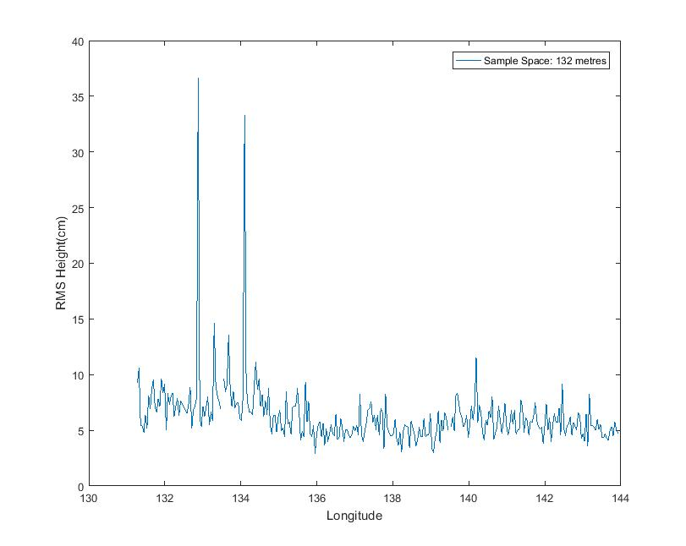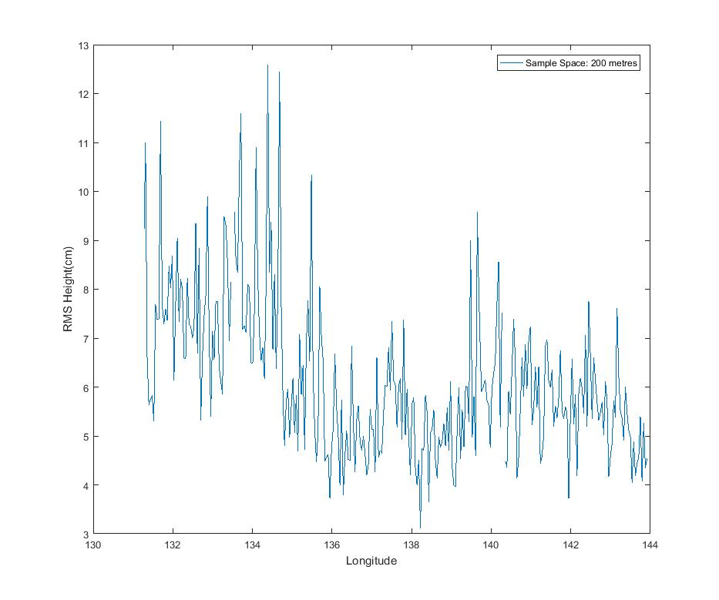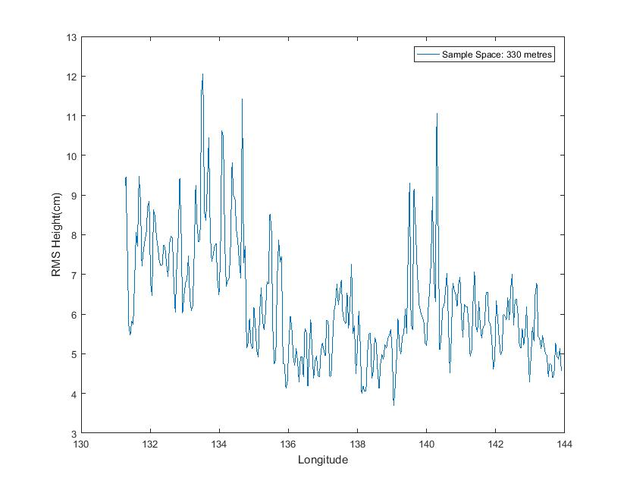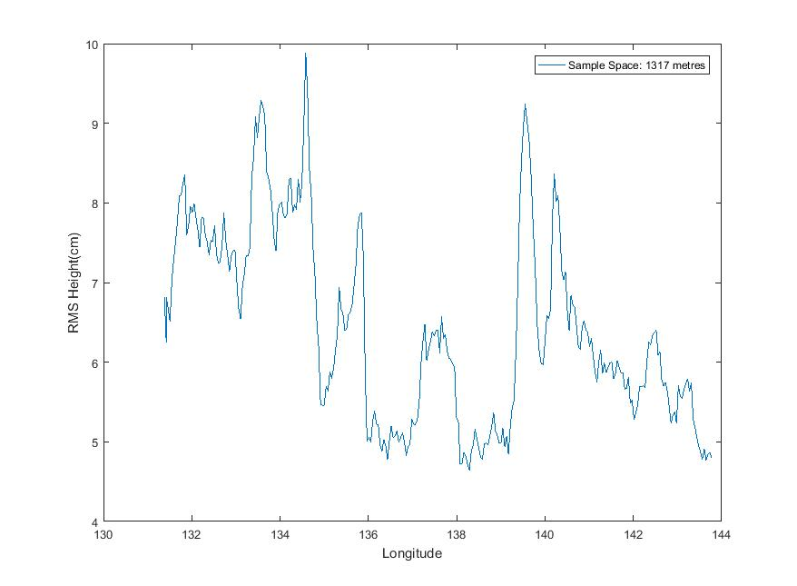

Fig. Effects of sample space on roughness calculation for 132 m, 200 m, 330 m and 1317 m

Since the roughness measurement at 200m matched closely with laser RMS while maintaining the local variations in roughness the sample space of 200m was used which also had enough samples for stable statistics. The echo amplitudes of the ice surface and ice bed are thus fitted using rice distribution for every 200 m with overlapping of every 100m to calculate the coherent and incoherent powers and then from power statistics, derive the RMS height of the surface [191].

*Sensitivity to surface tracking*

For calculation of roughness statistics it is imperative that the surface amplitude values given to the fitting are proper and representative of the actual surface otherwise the fitting may yield coherent and incoherent powers improperly. Here the automatic tracker of CReSIS is used and is expected to be accurate enough. Sometimes due to incorrect tracking at rougher interfaces few values are different however the overall roughness as a whole has matched the expected results.

**5.3 Roughness Measurements from ATM**

In addition to the roughness measurement calculations from MCoRDS, ATM has also supplemented these calculations. Airborne Topographic Mapper (ATM), airborne laser altimeter measures the surface elevation based on the two-way travel time of laser pulses along with the differential GPS and aircraft attitude information. The along-track resolution spacing is usually 3-4 m with laser footprint of ~1m. The primary data product of ATM is QFIT, which is dense surface elevation measurements []. A QFIT file is a collection of geolocated laser shots tagged with time and elevation. It is condensed resampled into ICESSN which fits a plane to the block of points selected at regular intervals (0.5 sec) along track with overlapping of 50% between successive blocks [2017]. The radar lines of MCoRDS coincide with the track 0 of ICESSN data. ICESSN data has along-track resolution of 80 meters and hence the RMS height from this laser system is calculated by the interpolation for the corresponding radar locations. It can be seen that the roughness patterns for these two systems match closely with each other.

**5.4 Roughness Measurements from KuBand Altimeter**

In addition, Operation IceBridge missions also employ the Ku-band altimeter developed by CReSIS which is an Ultra Wideband Frequency (UWB) Modulated Continuous wave Wave (FMCW) radar operating usually from 12-18 GHz [2119]. It provides high precision surface elevation measurements over polar ice sheets. The along-track resolution interval of the data from the Ku- band altimeter is about 0.2 meters after hardware presums.

**5.5 Application**

The radar data used for analysis were collected by CReSIS using MCoRDS in 2010-2014 season in Greenland. The particular segment 20141026_02 from Antarctica, as shown in the red line in Fig.1, is used to analyze the validity of the above methods because of the good quality of data, and the variable surface roughness as seen from the Ku-band altimeter in Fig. 2. Areas with smooth surface can be seen in Fig. 2a and rougher surface from Fig. 2b with their corresponding Ku-band radar echograms in Fig. 2c and Fig. 2d.

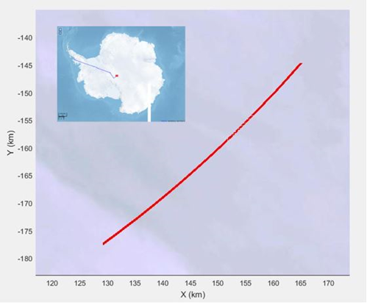

Fig. 1. Area used for Roughness Comparison and Verification

The amplitude distribution is fitted to the Rician distribution for every 500 data records from MCoRDS (i.e. about 200-m along-track distance) to derive the surface RMS height according to Eq. (3) to Eq. (6). For the purpose of validation, the RMS height was also derived for the corresponding radar locations using Ku-band and laser altimeter data. Figure 3 shows the comparison between the surface roughness measurements obtained from three systems, with the red indicating radar, blue indicating laser and green indicating Ku-band measurements. It can be clearly observed that the RMS height calculated corresponds to the surface features seen in the Ku-band altimeter image. The rougher surface features from the echogram coincide with the corresponding higher value of RMS height whereas same for the comparatively smoother surfaces of lower RMS value.

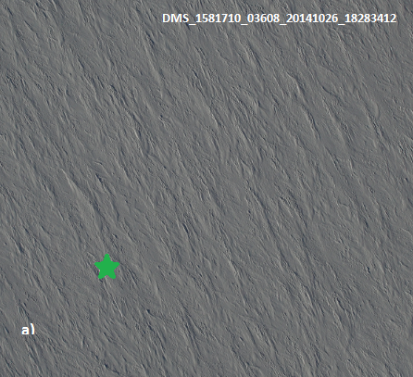 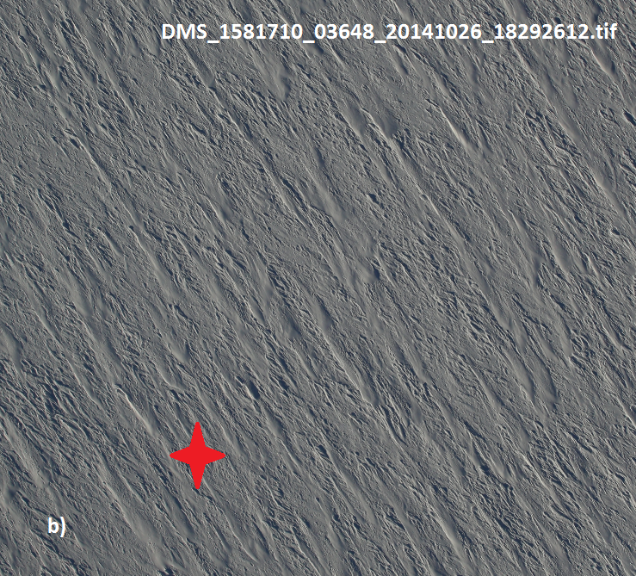

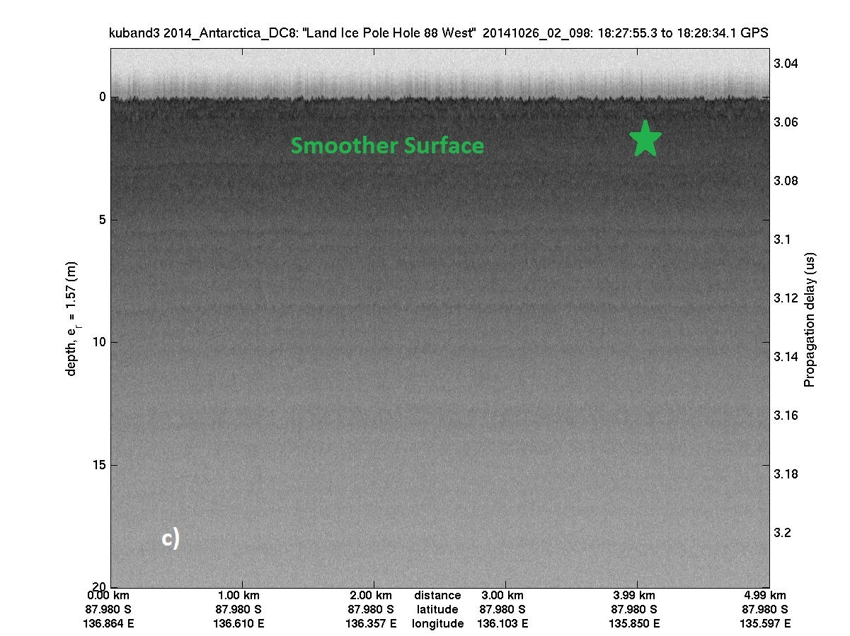 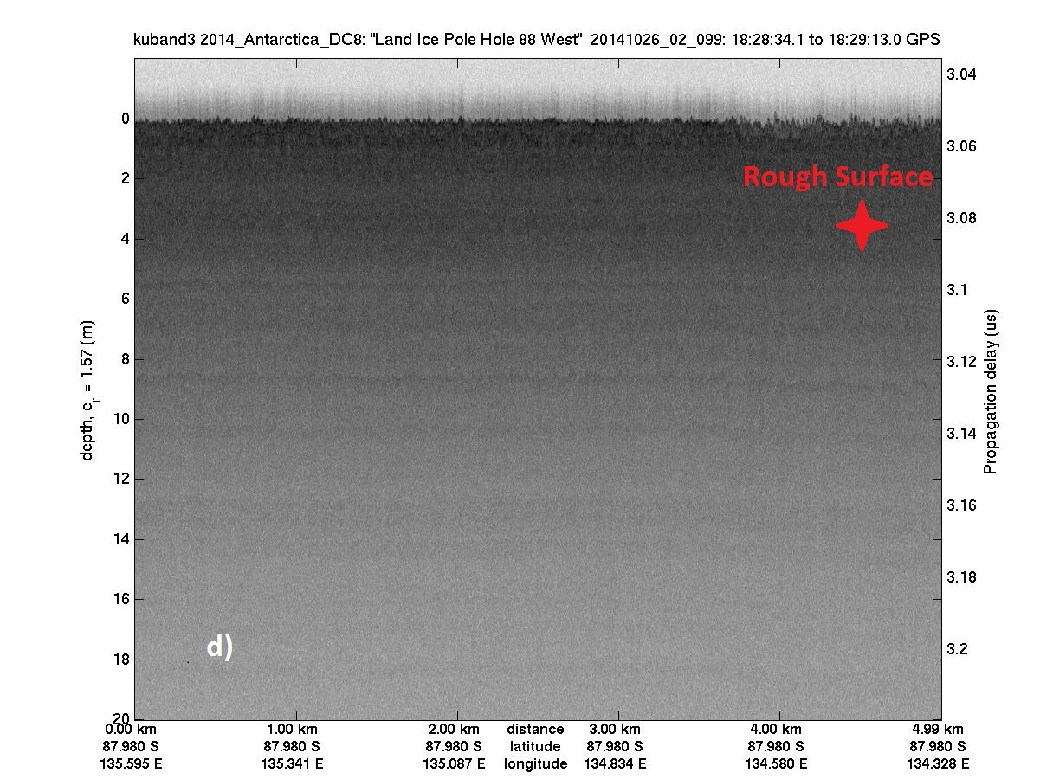

Fig.2. DMS pictures of areas with Smoother (a) and Rougher (b) Surfaces [30]. Radar Echograms obtained from Ku-Band Altimeter

showing corresponding smooth (a) and rough areas (b) [14]

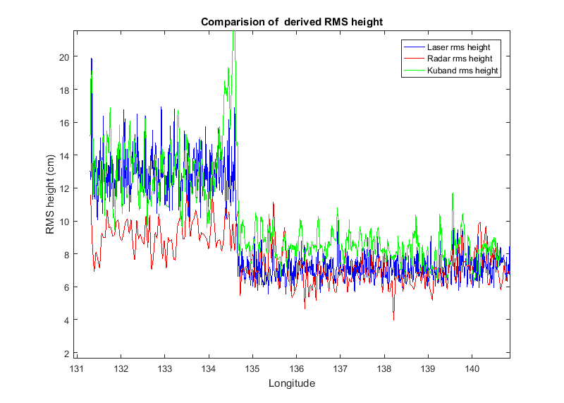

Fig. 3. Surface RMS heights obtained from MCoRDS (red), ATM (blue) and Ku-Band Altimeter (green)

It can be distinguished that the areas with higher RMS in laser data are also seen rough by the radar. However, there is a certain bias which can be owed to the facts that these are two different systems operating with different system parameters and surface roughness is the inherent property of radar specifications [22]. The RMS heights detected by radar are bounded for rougher area and this might be the more evident amplitude fading effects with increasing roughness [19]. In addition, the RMS heights derived from the Ku-band altimeter measurements are similar.

Following the comparisons and verifications, we used the same method to determine the surface and bed roughness of Peterman Glacier and Jakobshavn glacier, which can be later used to calibrate the calculation of the ice bed reflectivity and are explained in Chapter 7.